Lenten Series 2021
Session #4 The Second Temptation of Christ
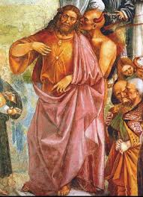
(Detail of The Deeds of Antichrist by Luca Signorelli, c. 1505,
showing the Antichrist directed by Satan; in the Duomo, Orvieto, Italy.)

Thank you for viewing Fr. Edgar’s presentation on Jesus in the desert and a deeper exploration of “who” the Devil is. You can review the Bishop Barron video here:
https://www.youtube.com/watch?v=IED3S-vJ5AU

Reflection Questions
1. Now that we know that the dark power is still prowling in this world, how can we make the right choices in life?
2. As the battle against the dark powers continues to this day, how would we now prepare ourselves to defend ourselves, our family, our relatives, our friends, and our community?
3. Of the following 5 Catholic “weapons” that we can employ to battle the Enemy, which has been most useful to you historically? Which might you employ now?
Mass
Eucharist
Confession
Sacraments
Saints

