Lenten Series 2021
Session #6 The Triduum: One Single Event
(presented by Fr. Ritche, Pastor)
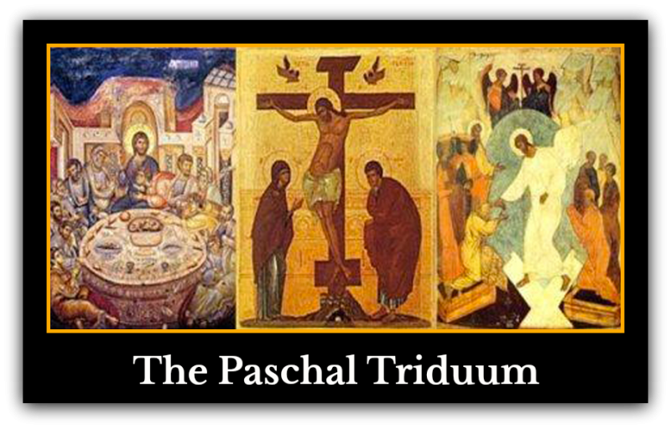
Reflection Questions
- What gestures in the Triduum Liturgy guide me in my prayer and service? Why?
- How do I identify this year with the ancient people of Israel and their Passover?
- If were at the Last Supper and Jesus came to wash my feet, how would I feel? How would I react?

Some Triduum elements to inspire reflection and prayer:
Washing of the feet
The Last Supper/feasting together
The Altar of Repose
Walking the Stations of the Cross
Veneration of the cross
Fasting
Praying by candlelight
Litany of the Saints: pray for the Elect and recall your own “saint name”
Meditating on the Vigil scripture readings
Wearing white
Recalling your baptism or the baptism of your children, grandchildren, etc.
Singing Alleluia!

